附件：《比赛系数X分值对应表》
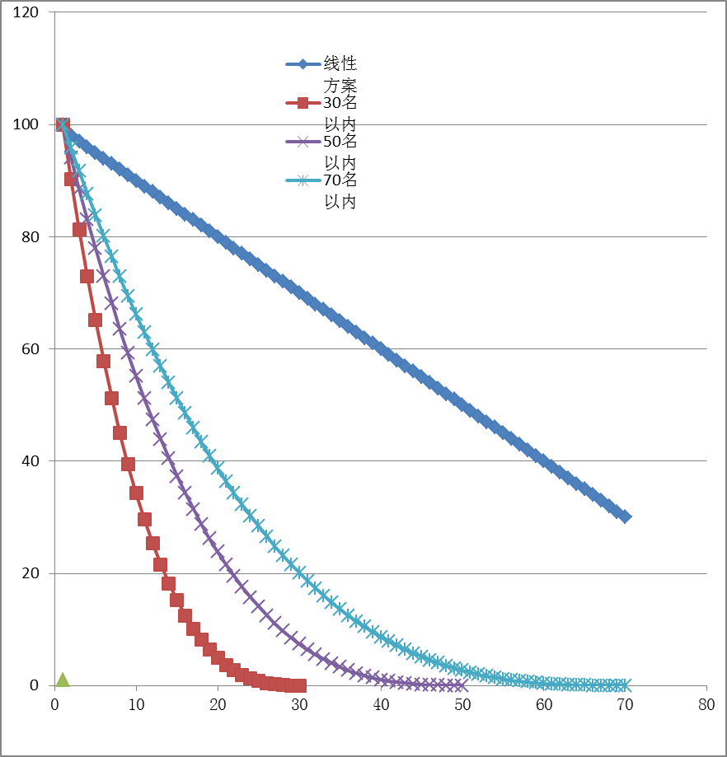
人数  名次 | 10 | 20 | 30 | 40 | 50 | 60 | 70 | 80 | 90 | 100 | 110及以上
1 | 100.0 | 100.0 | 100.0 | 100.0 | 100.0 | 100.0 | 100.0 | 100.0 | 100.0 | 100.0 | 100.0
2 | 72.9 | 85.7 | 90.3 | 92.7 | 94.1 | 95.1 | 95.8 | 96.3 | 96.7 | 97.0 | 97.3
3 | 51.2 | 72.9 | 81.3 | 85.7 | 88.5 | 90.3 | 91.7 | 92.7 | 93.5 | 94.1 | 94.6
4 | 34.3 | 61.4 | 72.9 | 79.1 | 83.1 | 85.7 | 87.7 | 89.2 | 90.3 | 91.3 | 92.0
5 | 21.6 | 51.2 | 65.1 | 72.9 | 77.9 | 81.3 | 83.8 | 85.7 | 87.3 | 88.5 | 89.5
6 | 12.5 | 42.2 | 57.9 | 67.0 | 72.9 | 77.0 | 80.1 | 82.4 | 84.2 | 85.7 | 87.0
7 | 6.4 | 34.3 | 51.2 | 61.4 | 68.1 | 72.9 | 76.4 | 79.1 | 81.3 | 83.1 | 84.5
8 | 2.7 | 27.5 | 45.1 | 56.2 | 63.6 | 68.9 | 72.9 | 76.0 | 78.4 | 80.4 | 82.1
9 | 0.8 | 21.6 | 39.4 | 51.2 | 59.3 | 65.1 | 69.5 | 72.9 | 75.6 | 77.9 | 79.7
10 | 0.1 | 16.6 | 34.3 | 46.5 | 55.1 | 61.4 | 66.2 | 69.9 | 72.9 | 75.4 | 77.4
11 |  | 12.5 | 29.6 | 42.2 | 51.2 | 57.9 | 63.0 | 67.0 | 70.2 | 72.9 | 75.1
12 |  | 9.1 | 25.4 | 38.1 | 47.5 | 54.5 | 59.9 | 64.2 | 67.6 | 70.5 | 72.9
13 |  | 6.4 | 21.6 | 34.3 | 43.9 | 51.2 | 56.9 | 61.4 | 65.1 | 68.1 | 70.7
14 |  | 4.3 | 18.2 | 30.8 | 40.5 | 48.1 | 54.0 | 58.7 | 62.6 | 65.9 | 68.6
15 |  | 2.7 | 15.2 | 27.5 | 37.3 | 45.1 | 51.2 | 56.2 | 60.2 | 63.6 | 66.5
16 |  | 1.6 | 12.5 | 24.4 | 34.3 | 42.2 | 48.5 | 53.6 | 57.9 | 61.4 | 64.4
17 |  | 0.8 | 10.2 | 21.6 | 31.4 | 39.4 | 45.9 | 51.2 | 55.6 | 59.3 | 62.4
18 |  | 0.3 | 8.1 | 19.0 | 28.7 | 36.8 | 43.4 | 48.8 | 53.4 | 57.2 | 60.4
19 |  | 0.1 | 6.4 | 16.6 | 26.2 | 34.3 | 41.0 | 46.5 | 51.2 | 55.1 | 58.5
20 |  | 0.0 | 4.9 | 14.5 | 23.8 | 31.9 | 38.7 | 44.3 | 49.1 | 53.1 | 56.6
21 |  |  | 3.7 | 12.5 | 21.6 | 29.6 | 36.4 | 42.2 | 47.1 | 51.2 | 54.8
22 |  |  | 2.7 | 10.7 | 19.5 | 27.5 | 34.3 | 40.1 | 45.1 | 49.3 | 53.0
23 |  |  | 1.9 | 9.1 | 17.6 | 25.4 | 32.2 | 38.1 | 43.1 | 47.5 | 51.2
24 |  |  | 1.3 | 7.7 | 15.7 | 23.5 | 30.3 | 36.2 | 41.3 | 45.7 | 49.5
25 |  |  | 0.8 | 6.4 | 14.1 | 21.6 | 28.4 | 34.3 | 39.4 | 43.9 | 47.8
26 |  |  | 0.5 | 5.3 | 12.5 | 19.8 | 26.6 | 32.5 | 37.7 | 42.2 | 46.1
27 |  |  | 0.2 | 4.3 | 11.1 | 18.2 | 24.8 | 30.8 | 36.0 | 40.5 | 44.5
28 |  |  | 0.1 | 3.4 | 9.7 | 16.6 | 23.2 | 29.1 | 34.3 | 38.9 | 43.0
29 |  |  | 0.0 | 2.7 | 8.5 | 15.2 | 21.6 | 27.5 | 32.7 | 37.3 | 41.4
30 |  |  | 0.0 | 2.1 | 7.4 | 13.8 | 20.1 | 25.9 | 31.1 | 35.8 | 39.9
31 |  |  |  | 1.6 | 6.4 | 12.5 | 18.7 | 24.4 | 29.6 | 34.3 | 38.5
32 |  |  |  | 1.1 | 5.5 | 11.3 | 17.3 | 23.0 | 28.2 | 32.9 | 37.0
33 |  |  |  | 0.8 | 4.7 | 10.2 | 16.0 | 21.6 | 26.8 | 31.4 | 35.7
34 |  |  |  | 0.5 | 3.9 | 9.1 | 14.8 | 20.3 | 25.4 | 30.1 | 34.3
35 |  |  |  | 0.3 | 3.3 | 8.1 | 13.6 | 19.0 | 24.1 | 28.7 | 33.0
36 |  |  |  | 0.2 | 2.7 | 7.2 | 12.5 | 17.8 | 22.8 | 27.5 | 31.7
37 |  |  |  | 0.1 | 2.2 | 6.4 | 11.5 | 16.6 | 21.6 | 26.2 | 30.4
38 |  |  |  | 0.0 | 1.8 | 5.6 | 10.5 | 15.5 | 20.4 | 25.0 | 29.2
39 |  |  |  | 0.0 | 1.4 | 4.9 | 9.6 | 14.5 | 19.3 | 23.8 | 28.0
40 |  |  |  | 0.0 | 1.1 | 4.3 | 8.7 | 13.5 | 18.2 | 22.7 | 26.9
41 |  |  |  |  | 0.8 | 3.7 | 7.9 | 12.5 | 17.1 | 21.6 | 25.8
42 |  |  |  |  | 0.6 | 3.2 | 7.1 | 11.6 | 16.1 | 20.5 | 24.7
43 |  |  |  |  | 0.4 | 2.7 | 6.4 | 10.7 | 15.2 | 19.5 | 23.6
44 |  |  |  |  | 0.3 | 2.3 | 5.7 | 9.9 | 14.2 | 18.5 | 22.6
45 |  |  |  |  | 0.2 | 1.9 | 5.1 | 9.1 | 13.4 | 17.6 | 21.6
46 |  |  |  |  | 0.1 | 1.6 | 4.6 | 8.4 | 12.5 | 16.6 | 20.6
47 |  |  |  |  | 0.1 | 1.3 | 4.0 | 7.7 | 11.7 | 15.7 | 19.7
48 |  |  |  |  | 0.0 | 1.0 | 3.5 | 7.0 | 10.9 | 14.9 | 18.8
49 |  |  |  |  | 0.0 | 0.8 | 3.1 | 6.4 | 10.2 | 14.1 | 17.9
50 |  |  |  |  | 0.0 | 0.6 | 2.7 | 5.8 | 9.5 | 13.3 | 17.1
51 |  |  |  |  |  | 0.5 | 2.3 | 5.3 | 8.8 | 12.5 | 16.2
52 |  |  |  |  |  | 0.3 | 2.0 | 4.8 | 8.1 | 11.8 | 15.4
53 |  |  |  |  |  | 0.2 | 1.7 | 4.3 | 7.5 | 11.1 | 14.7
54 |  |  |  |  |  | 0.2 | 1.4 | 3.8 | 6.9 | 10.4 | 13.9
55 |  |  |  |  |  | 0.1 | 1.2 | 3.4 | 6.4 | 9.7 | 13.2
56 |  |  |  |  |  | 0.1 | 1.0 | 3.1 | 5.9 | 9.1 | 12.5
57 |  |  |  |  |  | 0.0 | 0.8 | 2.7 | 5.4 | 8.5 | 11.8
58 |  |  |  |  |  | 0.0 | 0.6 | 2.4 | 4.9 | 8.0 | 11.2
59 |  |  |  |  |  | 0.0 | 0.5 | 2.1 | 4.5 | 7.4 | 10.6
60 |  |  |  |  |  | 0.0 | 0.4 | 1.8 | 4.1 | 6.9 | 10.0
61 |  |  |  |  |  |  | 0.3 | 1.6 | 3.7 | 6.4 | 9.4
62 |  |  |  |  |  |  | 0.2 | 1.3 | 3.3 | 5.9 | 8.8
63 |  |  |  |  |  |  | 0.1 | 1.1 | 3.0 | 5.5 | 8.3
64 |  |  |  |  |  |  | 0.1 | 1.0 | 2.7 | 5.1 | 7.8
65 |  |  |  |  |  |  | 0.1 | 0.8 | 2.4 | 4.7 | 7.3
66 |  |  |  |  |  |  | 0.0 | 0.7 | 2.1 | 4.3 | 6.8
67 |  |  |  |  |  |  | 0.0 | 0.5 | 1.9 | 3.9 | 6.4
68 |  |  |  |  |  |  | 0.0 | 0.4 | 1.7 | 3.6 | 6.0
69 |  |  |  |  |  |  | 0.0 | 0.3 | 1.5 | 3.3 | 5.6
70 |  |  |  |  |  |  | 0.0 | 0.3 | 1.3 | 3.0 | 5.2
71 |  |  |  |  |  |  |  | 0.2 | 1.1 | 2.7 | 4.8
72 |  |  |  |  |  |  |  | 0.1 | 0.9 | 2.4 | 4.5
73 |  |  |  |  |  |  |  | 0.1 | 0.8 | 2.2 | 4.1
74 |  |  |  |  |  |  |  | 0.1 | 0.7 | 2.0 | 3.8
75 |  |  |  |  |  |  |  | 0.0 | 0.6 | 1.8 | 3.5
76 |  |  |  |  |  |  |  | 0.0 | 0.5 | 1.6 | 3.2
77 |  |  |  |  |  |  |  | 0.0 | 0.4 | 1.4 | 3.0
78 |  |  |  |  |  |  |  | 0.0 | 0.3 | 1.2 | 2.7
79 |  |  |  |  |  |  |  |  | 0.2 | 1.1 | 2.5
80 |  |  |  |  |  |  |  |  | 0.2 | 0.9 | 2.2
81 |  |  |  |  |  |  |  |  | 0.1 | 0.8 | 2.0
82 |  |  |  |  |  |  |  |  | 0.1 | 0.7 | 1.8
83 |  |  |  |  |  |  |  |  | 0.1 | 0.6 | 1.6
84 |  |  |  |  |  |  |  |  | 0.0 | 0.5 | 1.5
85 |  |  |  |  |  |  |  |  | 0.0 | 0.4 | 1.3
86 |  |  |  |  |  |  |  |  | 0.0 | 0.3 | 1.2
87 |  |  |  |  |  |  |  |  | 0.0 | 0.3 | 1.0
88 |  |  |  |  |  |  |  |  | 0.0 | 0.2 | 0.9
89 |  |  |  |  |  |  |  |  |  | 0.2 | 0.8
90 |  |  |  |  |  |  |  |  |  | 0.1 | 0.7
91 |  |  |  |  |  |  |  |  |  | 0.1 | 0.6
92 |  |  |  |  |  |  |  |  |  | 0.1 | 0.5
93 |  |  |  |  |  |  |  |  |  | 0.1 | 0.4
94 |  |  |  |  |  |  |  |  |  | 0.0 | 0.4
95 |  |  |  |  |  |  |  |  |  | 0.0 | 0.3
96 |  |  |  |  |  |  |  |  |  | 0.0 | 0.3
97 |  |  |  |  |  |  |  |  |  | 0.0 | 0.2
98 |  |  |  |  |  |  |  |  |  |  | 0.2
99 |  |  |  |  |  |  |  |  |  |  | 0.1
100 |  |  |  |  |  |  |  |  |  |  | 0.1
101 |  |  |  |  |  |  |  |  |  |  | 0.1
102 |  |  |  |  |  |  |  |  |  |  | 0.1
103 |  |  |  |  |  |  |  |  |  |  | 0.0
104 |  |  |  |  |  |  |  |  |  |  | 0.0
105 |  |  |  |  |  |  |  |  |  |  | 0.0
106 |  |  |  |  |  |  |  |  |  |  | 0.0
107 |  |  |  |  |  |  |  |  |  |  | 0.0
108 |  |  |  |  |  |  |  |  |  |  | 0.0
109 |  |  |  |  |  |  |  |  |  |  | 0.0
110 |  |  |  |  |  |  |  |  |  |  | 0.0

