**China Sport Industry City Clubs Open Regatta International 2021**

**Notice of Race (Draft)**

**29 April-3 May 2021**

Organizing Authority (OA):

China Water Sports Administration, Chinese Yachting Association,

Qingdao Major International Sailing Events (Festival) Organizing Committee,

China Marine Sport School, China Sports Industry Group Co., Ltd.

China Olympic Sports Industry Co., Ltd.,

Qingdao Sports Development Center (Qingdao Sailing Administrative Center) in conjunction with Qingdao Tourist Group Ltd.

International FE28 Class Association, GSE Management, Qingdao Oriental Shadow Yacht Club Management Co., Ltd.,

Qingdao Jiguang Radio Sailing Club, Beijing Conworld Sports & Gaastra Sports and Leisure Co., Ltd

Navigation Flying Express Management Co., Ltd.,

**Olympic Sailing Center, Qingdao, China**

The notation “[NP]” in a rule means that a boat may not protest another boat for breaking that rule. This changes RRS 60.1(a).

The notation “[SP]” means the standard penalties may be used by race committee (RC) without hearing. This changes RRS 63.1 and A5. According to the situation, the penalty shall be the score of the best race of the day plus 3.

**Epidemic Prevention Requirements:**

1. All participants must not pass through or stay in a medium-to-high-risk area within 15 days; no exposure to COVID－19 cases or suspected cases, and provide the hospital nucleic acid test negative certificate within 7 days as required;
2. During the entire regatta (except for on the water races), competitors should consciously wear facial masks and get temperature testing as required;
3. Temperature measuring equipment may be set up on site, and temperature detection for staffs and participants will be carry out strictly . People who have fever and are in quarantine are not allowed to enter the venue. Body temperature exceeds 37.3 degrees or are found to have fever, cold, cough, etc., must cooperate with temporary medical observation;
4. Staffs and participants must conduct electronic health pass code verification when entering the venue. Those who do not have a health code or who are in doubt will not be allowed to enter the venue;
5. Disposable hand sanitizer is equipped on site for competitors to disinfect;
6. Staffs and participants shall register with their real names, and team leaders must have detailed information such as the identification card, work unit (company), contact numbers and other information of the team members;
7. The regatta (schedule) will be dynamically adjusted to cope with the changes in the epidemic prevention and control situation and national policies. The participating clubs enter the regatta on a voluntary basis. If the regatta is adjusted, postponed or cancelled, the entry fee will be refunded by the OA.
8. **RULES**
   1. The regatta will be governed by the rules as defined in The Racing Rules of Sailing (RRS).
   2. The rules for the handling of boats will apply, and will also apply to any time when the boats are on the water.
   3. Add to RRS 41 (e): help to recover from the water and return on board a crew member provided the return on board is at the approximate location of the recovery.
   4. No national/regional authority prescriptions will apply.
   5. If there is a conflict between languages the English text will take precedence.
   6. When RRS 20 applies, a boat may use <VHF81a> to indicate her call for the room to tack or her response.
   7. Teams should carry their own life jackets that comply with ISO12402-5 or higher、VHF marine portable radios and portable GPS.

**2 SAILING INSTRUCTIONS (SIs)**

The SIs will be available after registration.

**3 COMMUNICATIONS**

3.1 The on-line official notice board will be at the WeChat "CCOR Regatta Group".

3.2 [DP]While racing, except in an emergency, a boat shall neither make voice or data transmissions nor receive voice or data communications that are not available to all boats.

**4 ELIGIBILITY AND ENTRIES**

4.1 Eligible Boats

The OA plans to organize sixteen J80 and fifteen FAREAST 28R boats with third party liability insurance and valid certificates issued by the authority of the registered area. Teams may bring their own boats of the same classes to compete in the regatta.

There will be radio sailing classes in the regatta. For details of it, please refer to the <2021 CCOR Radio Sailing Notice of Race>.

4.2 Eligibility

4.2.1 Boats may be entered by their member national/area authority, cities, clubs or the owner of the boat approved by OA.

4.2.2 At least one helmsman on board of each boat shall have competent course racing skills and experience. Two competitors on board of each boat shall have experience for such type of regattas.

4.2.3 When the number of boats entered and registered on-site for one class is less than 4, the event of that class (group) will be cancelled; if the number of college fleet registrations reaches 8, the J80 college group will be added to the J80 event. For the college group, all competitors shall provide the proof of in-service teachers or students.

4.2.4 Have the personnel insurance prescribed as NoR21.

4.3 Entries

The registration time is from the publication of this notice of race to 17:00 on April 15, 2021. Entry Form, together with the documents and materials as the following, shall be received by ***kpeng@163.com*** or[***18678902329@163.com***](mailto:18678902329@163.com)no later than that time (The title of the email may indicates the name of the team):

4.3.1 Entry form with confirmed name list and declaration of the relevant regatta experience of the competitors as required by the NoR 4.2.2;

4.3.2 Team introduction, including text introduction within 400 words, photo and VCR of the crews/team.

4.3.3 Boats that not charted through the boat owner shall provide their boat’s certificate and insurance (copies) prescribed as NoR 21.

4.3.4 Paper Entry Form with signature of boat owner or the person in charge and the Disclaimer of Liability for crew shall be provided at On-Site Registration. The OA reserves the right to decline the entry due to the eligibility and number of the boats.

Entry form is available at

www. sports.gov.cn/qdhx/. Entry Procedure will be completed when receiving the confirmation of OA.

**The registration method of paying the fee first and submitting the registration form later will be declined by the OA.**

**5 FEES**

5.1 The following fees shall be paid when participating in the regatta:

Entry fee for each team is 3000 RMB. If persons of participating teams exceed the maximum limit of the class specified by the OA in NoR, the registration fee shall be paid at RMB 500 per person. For the fleets that apply for withdrawal before 20th April 2021, the OA will deduct 3% of the handling fee. Registration fee will not be refunded for those who withdraw after 20th April 2021 (except for unestablished classes caused by insufficient registration).

For charter please refer to NoR 15.

For equipment damage deposit please refer to NoR 15.

5.2 Teams who have received the entered confirmation may pay the entry fee and the equipment charter fee in advance by bank transfer to reserve the charter boat. The bank transfer information is as Addendum E.

5.3 The equipment damage deposit **must** be paid in cash at the on-site registration. Equipment Damage Deposit will be fully returned if equipment has no damage after the regatta. When damage occurred, according to the damage to the equipment, only part of, or no damage deposit will be returned.

Please send the registration information and payment records to the registration mailbox separately. Registration is considered valid after receiving confirmation from the OA.

**6 CREW LIMITATIONS**

The table below specifies the minimum and maximum number of the team member that shall be on board during racing for each class:

|  |  |  |
| --- | --- | --- |
| Class | Minimum number persons | Maximum number of persons |
| FAREAST 28R | 4 | 6 |
| J80 | 3 | 6 |

1. [NP]**ADVERTISING**
   1. World Sailing Advertising Code will be applied. The OA has the right to reject the team’s advertisements that conflict with government regulations and the regatta’s sponsors. For any doubts, please communicate with the OA as early as possible. All possible advertisements on the boat shall be briefly listed while registration. If there are any changes in advertisements, the OA should be informed.
   2. Teams may display their team’s name, image or advertising on each side of the hull and clean them up after the regatta. The location of such advertising is shown as Addendum C and the maximum size shall not be larger than the size for FE28R / J80: 450mm high and 2000mm long.
   3. Boats should display the advertsing of the regatta’s sponsors, such as the bow and backstay flags, according to NoR and SIs. Before leaving the port, before the start of the race, and after the finish of the race, the boats should display the regatta flag. Advertising materials such as sponsor logo, backstay flag and regatta flag will be supplied by the OA. If the team damages the advertising supplied by the OA deliberately, the OA has the right to protest.
2. **RACE DISCIPLINE**

The event will consist of course races and a coastal race.

1. **SCHEDULE**

|  |  |  |
| --- | --- | --- |
| **Date/Time** | **Activity** | **Location** |
| 29th April 2021 | Registration Day |  |
| 0900-1200 | Registration, Boat Distribution, Practice |  |
| 1600 | Briefing |  |
| 1800 | Opening Ceremony |  |
| 30th April 2021 | Racing Day |  |
| 1030 | First Warning Signal |  |
| 1st May 2021 | Racing Day |  |
| 1030 | First Warning Signal |  |
| 2nd May 2020 | Racing Day |  |
| 1030 | First Warning Signal |  |
| 3rd May 2021 | Racing Day |  |
| 1030 | First Warning Signal |  |
| 1400 | No More Warning Signal |  |
| 1700 | Prize Giving Ceremony |  |

**10 EQUIPMENT INSPECTION**

10.1 The boats shall be available for equipment inspection on-site at any time.

10.2 Teams may bring their own equipment including spinnaker comply with the requirements, but they should be measured before racing.

1. **VENUE**

Addendum A and B shows the race areas. They are for reference only, no ground of redress shall be made on them.

1. **COURSE**

The course will be published in the SIs.

**13 PENALTY SYSTEMS**

13.1 RRS 44.1 is changed so that the Two-Turns Penalty is replaced by the One-Turn Penalty.

13.2 Decisions of protest committee will be final as provided in RRS 70.5 or 70.5(b).

**14 SCORING**

14.1 Ten races will be scheduled. One race is required to be completed to constitute a series.

14.2 When fewer than 5 races have been completed, a boat’s series score will be the total of her race scores.

14.3 When 5 or more races have been completed, a boat’s series score will be the total of her race scores excluding her worst score.

14.4 The coastal race for J80& FE28R will be an one off race and will be scored separately. The result of coastal race will be added to the series score as one race and cannot be excluded.

**15 CHARTER BOATS**

15.1 The OA has negotiated with the boat owners the special charter fees for the regatta as the following:

|  |  |  |  |  |
| --- | --- | --- | --- | --- |
| **Class (amount of boats)** | **Charter** | **Pro-event Charter** | **Damage Deposit** | **Boat Owner** |
| J80 (16) | 8000 | 2500per day | 7000 | CMSS |
| FAREAST 28R (15) | 6000 | 2000per day | 6000 | CMSS |

15.2 Boats may be charted for the regatta from 29th April to 3rd May 2021. If you need the boats three days before 29th April for practicing, the charter fee for those days is as showed above. Please contact the boat owner regarding this issue before you arrive at the venue.

15.3 Equipment provided by the OA is distributed by draw. After the return of equipment is qualified by the OA, the equipment deposit will be refunded. If any damage occurred, compensation shall be paid.

15.4 No ground of redress shall be made on the quality and failure of the chartered equipment.

1. **[DP] BERTHING**

Boats shall be kept in their assigned places or other designated area. The OA provides free berths for boat that not chartered through the boat owner from 27th April to 4th May (No caring responsibility from the OA).

**17 [DP] HAUL-OUT RESTRICTIONS**

Keelboats shall not be hauled out during the event except with and according to the terms of prior written permission of the race committee.

**18 [DP] DIVING EQUIPMENT AND PLASTIC POOLS**

Underwater breathing apparatus and plastic pools or their equivalent shall not be used around keelboats between the preparatory signal of the first race and the end of the event.

**19 DATA PROTECTION**

19.1 For safety reasons, it is possible for the boat to carry the trackers provided by the OA. If the tracker malfunctions or ceases to operate, the location information must be reported in other ways in accordance with SIs.

19.2 The organizer has the right to place cameras on board for media purposes. For the boat who refuses to carry ’trackers and cameras supplied by the OA, the OA may decline her registrations, cancel her registration, or disqualify her race.

**20 RISK STATEMENTS**

20.1 RRS 3 states: ‘**The responsibility for a boat’s decision to participate in a race or to continue to race is hers alone**.’ By participating in this event each competitor agrees and acknowledges that sailing is a potentially dangerous activity with inherent risks. These risks include strong winds and rough seas, sudden changes in weather, failure of equipment, boat handling errors, poor seamanship by other boats, loss of balance on an unstable platform and fatigue resulting in increased risk of injury. Inherent in the sport of sailing is the risk of permanent, catastrophic injury or death by drowning, trauma, hypothermia or other causes.

20.2 All crew members shall sign the <Disclaimer of Liability> provided by the OA.

**21 INSURANCE**

Each competitor shall be insured with valid personal accidentinsurance with a minimum cover of 500,000RMB per incident or the equivalent. Each participating boat that not chartered through the OA shall be insured by the team with valid third-party liability insurance within competition area with a minimum cover of 1000,000RMB per competition boat or the equivalent.

**22 [NP][DP]MEDIA RIGHTS AND LIMITATIONS**

22.1 Each participating boat should know that:

* The OA owns all the media rights of this regatta and shall exert theseright at any appropriate time;
* All members of the team shall unconditionally grant the OA the permanent right to publish and disseminate their names, images and profiles, as well as the photos, videos and audio recordings of the boats and crews before, during and after the regatta, regardless of the purpose and through any media around the world.
* Team members may accept interviews with media representatives approved by the OA before, during, and after the regatta, or provide interview materials. The content may include the regatta itself, the expected performance and strategy of the team, but no negative comments or interview materials that will cause harm, interference, or adverse effects on the OA, its officials and employees, the race committee, the protest committee, the measurers, the current or past sponsors.

22.2 Those who are deemed to have violated the above regulations by the organizer or race committee may be penaltied accordingly

**23 PRIZES**

23.1 Medals and certificates of result will be awarded to top 3 positions in each class/group which exceeds 8 boats. Certificates of result will be awarded from fourth to sixth positions. When less than 8 boats, the number of places that will be awarded prizes will be that of the total registered boats minus three.

23.2 For the series race of Class J80&FE28R, the first prize is 30,000RMB; the second prize is 20,000RMB; the third prize is 10,000RMB.

23.3 No separate prize bouns for college groups. All prizes are pre-tax amounts.

23.4 The OA and sponsors may provide other awards to the top ranked sailors.

1. **MORE INFORMATION**

For entry and more information, please contact:

**Mr Kangpeng;**

Mobile: +86-13954275197(the same number for wechat)

E-mail: kpeng@163.com

**Miss HouJiaYin**

Mobile: +8618678902329(the same number for wechat)

E-mail:18678902329@163.com

**Addendum A: Racing Area for Course Races**

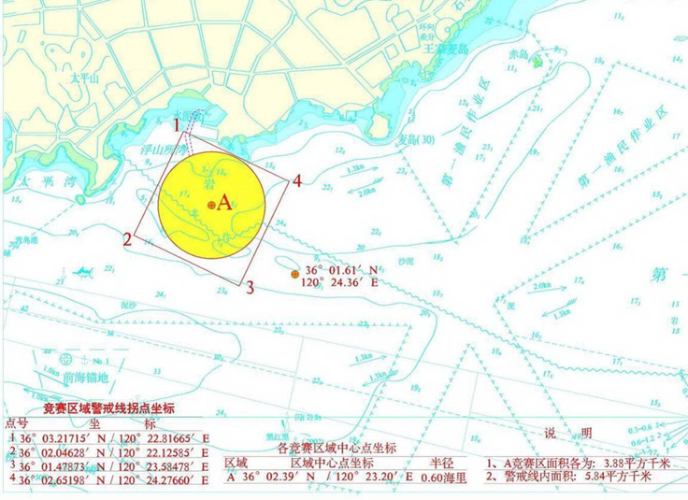

**Addendum B: Racing Area for Coastal Race**

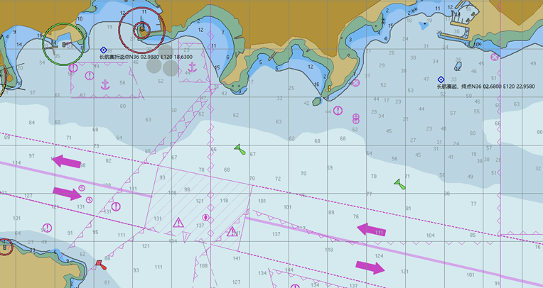

**Addendum C: ‘TEAM’ Space on Each Side of the Hull**

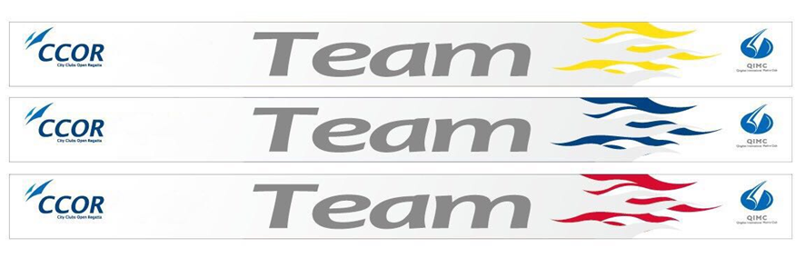

**Addendum D: ENTRY FORM FOR CCOR 2021**

<http://www.sport.gov.cn/qdhx/>

**Addendum E: More Information About the Payment of the Fee**

1. The invoice of teams needs to be issued with unit account, please provide detailed invoicing information. This information must be exactly the same as the remittance account. If a unit account invoice needs to be issued after the card is swiped, the bank card related information must be consistent with the unit account information.

**2. Paying the registration fee and equipment charter in advance may help OA to reserve entries for teams. For the entry fee and equipment charter from CMSS, the bank transfer information is as the following:**

Account Name: Qingdao National Marine Sport School

Bank Address: ICBC (Qingdao) 4th Sub Branch of Shinan, Qingdao

Account Number: 38030 2791 9200 172 316

Contact details:

LI Xianxian

Mobile: +86-18562581868

Office: +86 532 66560106

E-mail: [xianxian122143811@163.com](mailto:xianxian122143811@163.com)

**Addendum F: ACCOMMODATION AND OTHER ARRANGEMENT**

Hope the following hotel special offers can help you:

1. Qingdao Haier Intercontinental Hotel (1 minute to the venue by walk)

98 Macao Rd, Qingdao, 266071, China

Name: Dong Dai

Mobile: +86 15898871205

E-mail:dane.dong@icqingdao.com

Name: Han XiaoShan

Mobile: +86 15953257215

E-mail:rita.han@icqingdao.com

Agreed Prices:·city view double bed or king bed room: 700 RMB (double breakfast)

·sea view double bed or king bed room: 800 RMB (double breakfast)

·Executive city view double bed or king bed room: 800 RMB (double breakfast and executive lounge)

·Executive sea view double bed or king bed room: 950 RMB (double breakfast and executive lounge)

RMB 300 per night will be add from 1st to 3rd May

(B) CNFE Hotel (1 minute to the venue by walk)

12 Xinhui Rd., Qingdao, 266000, China

Name：Yin He

Mobile：+8618363984378

E-mail：1005477152@qq.com

Agreed Prices: **Prices for 29th April**

· king bed or double bed room: 400RMB (double breakfast)

· loft king bed (single bed)room: 500RMB (double breakfast)

·loft family (two beds) room: 550RMB (double breakfast)

**Prices for 30th April to 2nd May**

· king bed or double bed room: 700RMB (double breakfast)

· loft king bed (single bed) room: 800RMB (double breakfast)

·loft family (two beds) room: 850RMB (double breakfast)

(C) Qingdao Kunlun Heyue Hotel (1 minute to the venue by walk)

Name: Tan Yong

Mobile: +8618661827167

Name: Huang Longbo

Mobile: +8618661852831

Agreed Prices:

**Price for 29th April to 30th April:**

**·**superior room: 400RMB (include breakfast)

·sea view room: 550 RMB (include breakfast)

**Price for 1st May to 3rd May:**

**·**superior room: 500RMB (include breakfast)

**·**sea view room: 650 RMB (include breakfast)

(D) Hanting Olympic Hotel (8 minutes to the venue by walk)

Name：Chen Xiangcheng

Mobile：+8615264271902

E-mail：a140926@126.com

**Price before 30th April:**

Superior king bed or double bed room: 180RMB

**Price for 1st to 3rd May:**

Superior king bed or double bed room: 420RMB (include breakfast)

These prices are valid for booking before 10th April 2021