**国际赛事管理规程**

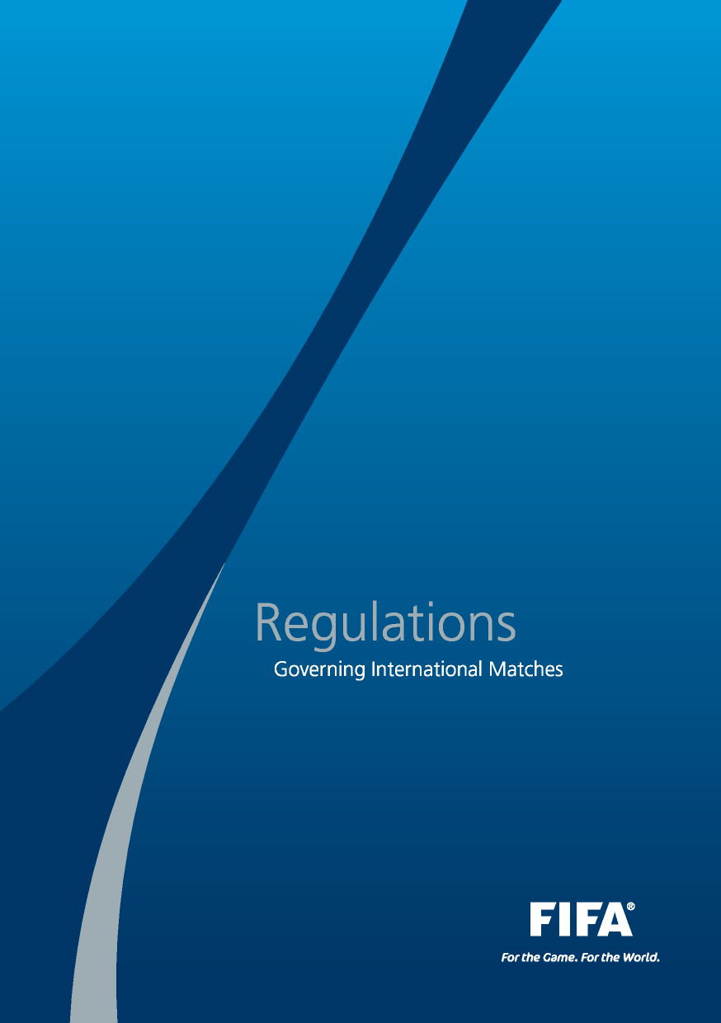



**dération Internationale de Football Association国际足球联合会**

President主席: Joseph S. Blatter

Secretary General秘书长: Jérôme Valcke

Address地址: FIFA

FIFA-Strasse 20 P.O. Box

8044 Zurich Switzerland

Tel电话: +41-(0)43-222 7777

Fax传真: +41-(0)43-222 7878

Internet网站: www.FIFA.com



**国际赛事管理规程**

Regulations

Governing International Matches

|  |  |
| --- | --- |
| 2 **CONTENTS** |  |
| **English edition英文版** | **1-24** |
| Edition française法文版 | 25 – 48 |
| Edición española西班牙文版 | 49 – 72 |
| Deutsche Ausgabe德文版 | 73 – 96 |

**CONTENTS** 3

|  |  |  |
| --- | --- | --- |
| **Page页码** | **Article条款** | |
| 4 | **I.**  1 | **GENERAL PROVISIONS 总则**  Object 目标 |
| 4 | 2 | Scope 适用范围 |
| 4 | 3 | Definitions 定义 |
| 6 | 4 | General conditions 一般规定 |
| 6 | 5 | Name of International Matches or competitions 国际比赛或赛事名称 |
| 7 | 6 | Duties of Members 会员协会职责 |
| 8 | **II.**  7 | **INTERNATIONAL MATCHES 国际比赛**  Authorisation 批准 |
| 8 | 8 | Tier 1 International Matches 1级比赛 |
| 9 | 9 | Tier 2 International Matches 2级比赛 |
| 9 | 10 | Tier 3 International Matches 3级比赛 |
| 10 | **III.**  11 | **PROCEDURE 程序**  Member application procedures 会员协会申请程序 |
| 13 | 12 | FIFA and Confederation authorizations 国际足联和洲足联的批准许可 |
| 14 | **IV.**  13 | **NOTIFICATION, REPORTING AND REGISTRATION OF**  **INTERNATIONAL “A“ MATCHES**国际“A级”赛的通知、报告与注册  Notification 通知 |
| 14 | 14 | Reporting 报告 |
| 15 | 15 | Registration and impact on FIFA ranking 注册与对国际足联排名影响 |
| 16 | **V.**  16 | **LEVIES 税费**  Levies 税费 |
| 18 | 17 | Statement of account 财务报表 |
| 18 | 18 | Minimum levy 最少税费 |
| 19 | **VI. SANCTIONS 处罚**  19 Sanctions 处罚 | |
| 19 | **VII. FINAL PROVISIONS 最后条款**  20 Official languages 官方语言 | |
| 19 | 21 Adoption and enforcement 通过与执行 | |
| 20 | **ANNEXES 附件** | |

**内容** 3

|  |  |  |
| --- | --- | --- |
| **页码** | **条款** | |
| 4 | **I.**  1 | **总则**  目标 |
| 4 | 2 | 适用范围 |
| 4 | 3 | 定义 |
| 6 | 4 | 一般规定 |
| 6 | 5 | 国际比赛或赛事名称 |
| 7 | 6 | 会员协会职责 |
| 8 | **II.**  7 | **国际比赛**  批准 |
| 8 | 8 | 1级比赛 |
| 9 | 9 | 2级比赛 |
| 9 | 10 | 级比赛 |
| 10 | **III.**  11 | **程序**  会员协会申请程序 |
| 13 | 12 | 国际足联和洲足联的批准许可 |
| 14 | **IV.**  13 | 国际“A级”赛的通知、报告与注册  通知 |
| 14 | 14 | 报告 |
| 15 | 15 | 注册与对国际足联排名影响 |
| 16 | **V.**  16 | **税费**  税费 |
| 18 | 17 | 财务报表 |
| 18 | 18 | 最少税费 |
| 19 | **VI. 处罚**  19 处罚 | |
| 19 | **VII. 最后条款**  20 官方语言 | |
| 19 | 21 通过与执行 | |
| 20 | **附件** | |

Based on articles 73, 78, 79 and 80 of the FIFA Statutes, the Executive Committee has issued the following regulations

4 I.**GENERAL PROVISIONS**

1 **Object**

These regulations set forth the authorisations, notifications and other requirements for organising matches and/or competitions between teams belonging to different Members, or between teams belonging to the same Member but playing in a Third Country, or involving players or teams that are not affiliated to Members or provisional members of the confederations as set forth in art. 79 par. 1 of the FIFA Statutes.

2 **Scope**

1. These regulations apply to all International Matches.
2. These regulations apply equally to association football (men’s and women’s football), futsal and beach soccer.

3 **Definitions**

For the purpose of these regulations, the terms set out below are defined as follows:

Club Team: a team representing a club that is affiliated directly or indirectly to a Member.

Confederation: a group of associations recognised by FIFA that belong to the same continent (or assimilable geographic region).

根据国际足联章程第73、78、79和80条规定，执委会批准下列规程：

4 I. **总则**

**第一条 目标**

本规程依据国际足联章程第79条第1款的规定，对组织的相关比赛或赛

事所涉及的授权、通知和其它要求进行规定。此规定主要是针对不同会

员协会所属球队之间的比赛或赛事；同一会员协会所属球队在第三国进

行的比赛或赛事；以及参赛球员或运动队不隶属于会员协会或各洲足联

临时会员协会的比赛或赛事。

**第二条 适用范围**

1. 本规程适用于所有国际比赛。
2. 本规程对男子、女子足球、五人制足球以及沙滩足球具有同等效力。

**第三条 定义**

本规程中提到的术语具体定义如下：

**俱乐部队：**代表的俱乐部参赛的球队，该俱乐部直接或间接隶属于某会

员协会。

**洲足联：**被国际足联认可的属于同一个大洲（或地理上的同一个区域）

会员协会组成的团体组织。

International Match: a match between two teams (either two Representative Teams, two Club Teams, two Scratch Teams, one Representative Team and one Club Team, or a Representative Team or Club Team and a Scratch Team) belonging to different Members. Any competition that may include an International Match shall be subject to these regulations. For the purpose of authorisation, any match or competition played between two teams belonging to the same Member but in a Third Country shall be recognised as an International Match.

**I. GENERAL PROVISIONS** 5

International “A” Match: a match arranged by two Members and for which both Members field their first Representative Team (“A” Representative Team).

Member: an association that has been admitted into membership of FIFA by the FIFA Congress.

Representative Team: a team representing a Member (men or women).

Scratch Team: a team consisting of players not registered to the same club or Member, and/or composed of players who are no longer duly registered with one of the Members as they have finished their football career as a professional and/or amateur player.

Third Country: the territory of a Member upon which a match or competition is to be played and to which none of the teams participating in the match or competition is affiliated.

NB: Terms referring to natural persons are applicable to both genders. Any term in the singular applies to the plural and vice-versa.

**I. 总则** 5

**国际比赛：**是指不同会员协会所属的两支球队之间的比赛（两个会员协会代表队之间、两个俱乐部队之间、两个临时组成的球队之间、一个会员协会代表队与一个俱乐部队之间、一个会员协会代表队或俱乐部队与一个临时组成的球队之间）。任何赛事中如有一场比赛为国际比赛则应遵守本规程。同一会员协会所属的两支球队在第三国举行的比赛也被认定为国际比赛或国际赛事。

**国际“A”级比赛：**两个会员协会间安排的比赛，且各自派出国家队（国家一队）参加比赛。

**会员协会：**由国际足联代表大会通过并承认为会员的协会。

**代表队：**代表会员协会的球队（男子或女子）

**临时组成的球队：**参赛队球员由不属于同一个俱乐部或会员协会的球员组成，和（或）由已不再在某一会员协会注册的退役职业球员或业余球员组成。

**第三国：**在一个会员协会领土内举行的比赛或赛事，而任何一支参赛队都不隶属于该会员协会。

**性别与单复数：**本规程术语中的球队泛指男女性别，不分单复数。

4 **General conditions**

6 I. **GENERAL PROVISIONS**

_Pic21

1. International Matches may only be authorised by FIFA, the Confederations or a Member in accordance with these regulations.
2. The Member on whose territory any International Match is played is responsible for all communications with regard to any other authorisations that are required from another Member, the Confederation(s) and FIFA.
3. Each team participating in an International Match shall verify before the match is played that the required authorisation(s) have been issued by the relevant bodies in accordance with these regulations.
4. A Member shall inform the relevant Members and, if required, the Confederation(s) and/or FIFA about any match that was arranged and played on its territory and for which authorisation was either not sought or not given.
5. A first Representative Team shall only play one match per day.

5 **Name of International Matches or competitions**

1. The name used for matches and competitions may not refer to the existing official names of any competitions of FIFA, the Confederations or Members.
2. The terms that may be used to define an International Match or competition are those that give an appropriate political and geographical description of the countries or territories of the Members whose teams are involved in the match or competition, and over whose countries or territories the Members shall have sole control and jurisdiction.
3. FIFA and the Confederations reserve the right to approve all competition names.

**第四条 一般规定**

6 I. **总则**

_Pic21

1. 国际比赛只能由国际足联、各洲足联或会员协会根据此规程批准。
2. 比赛举行所在地的会员协会负责所有沟通事务及办理相关审批手续（参赛队所属会员协会、洲足联和国际足联所需要的批准文件）。
3. 各参赛队在参加国际比赛时应在赛前核查所需的批准文件是否已由相关部门根据本规程签发。
4. 任何在一个会员协会其领土内安排和举行的比赛，比赛举办地的会员协会应通知相关参赛队所属会员协会、洲足联和国际足联（如有需要）比赛是否已得到相应的批准。
5. A级代表队（国家一队）的比赛每天只能进行一场。

**第五条 国际比赛或赛事的名称**

**_Pic21**

1. 国际比赛和赛事的名称不得提及国际足联、洲足联或会员协会任何已有赛事的官方名称。
2. 国际比赛或赛事使用的名称可体现参赛队所属会员协会的国家或地区的适当的政治性或地理描述，且该会员协会对该国家或地区拥有唯一的控制或管辖权。
3. 国际足联和各洲足联保留批准所有赛事的名称的权利。

6 **Duties of Members**

**I. GENERAL PROVISIONS**  7 **79**

_Pic23

1. Members shall draw up their own regulations governing International Matches, which must comply fully with these regulations as well as those of the Confederations concerned.
2. Members must ensure that their own members respect these regulations, those of the Confederations concerned as well as their own regulations.
3. The Member on whose territory an International Match will be played shall be responsible for ensuring compliance with the applicable regulations. It shall be responsible for obtaining authorisation from FIFA, the Confederations and the other Members concerned, if required.
4. Members must reply to any written request with regard to their Representative Teams or their affiliated clubs in relation to an authorisation request from another Member, a Confederation or FIFA.
5. The Member on whose territory an International “A” Match is played shall be responsible for collecting all applicable levies and forwarding the appropriate amounts to FIFA and/or the Confederations concerned in good time. It also shall be responsible for preparing the required statement of accounts for the International Match and submitting it to FIFA and the Confederations and Members concerned in good time.

**I. 总则**  7

**第六条 会员协会职则**

_Pic23

1. 会员协会可以制定自己的国际比赛管理规程，但必须完全遵守本规程及各洲足联的相关规程。
2. 会员协会必须确保自己的会员遵守本规程、各洲足联相关规程以及会员协会的相关规程。
3. 国际比赛举办地的会员协会负责确保遵守适用的相关规程。如有要求，需确保获得国际足联、各洲足联和其他相关会员协会的批准和授权。
4. 会员协会必须回复来自参赛会员协会、洲足联或国际足联发出的与参赛代表队或所属俱乐部有关的书面授权申请。
5. 国际A级比赛举办地的会员协会应负责收取所有适用规定的税费并及时将正确的数额转给国际足联和/或相关洲足联。该会员协会还应负责按要求填写国际比赛财务报表并及时提交给国际足联、洲足联和相关会员协会。

8 **II. INTERNATIONAL MATCHES**

1. **Authorisation**
2. All International Matches must be authorised by the Members to which the participating teams are affiliated and by the Member on whose territory the match is to occur. Matches involving a Scratch Team must be authorised by the Members to which the players are affiliated.
3. All matches involving a first Representative Team (“A” Representative Team) or Scratch Team that require the authorisation of two or more Confederations must also be authorised by FIFA.
4. Matches involving a Scratch Team may not be played without the approval of FIFA and the Confederations and Members concerned, and approval shall be granted only in exceptional circumstances.
5. FIFA’s authorisation or FIFA’s refusal of authorisation is given by the FIFA general secretariat, whose decision shall be final and binding.
6. An authorisation does not entail liability on the part of FIFA, the Confederations or any Member in the event that any legal claims subsequently arise.
7. **Tier 1 International Matches**
8. For the purposes of these regulations, a Tier 1 International Match shall mean any International Match in which one of the teams participating is the first Representative Team (“A” Representative Team), a Scratch Team, or a Club Team that participates in one of the two highest divisions of a Member according to the national competition hierarchy of the Member concerned.

2．A summary of the authorisations required for Tier 1 International

Matches is set forth in Annexe A.

8 **II.国际比赛**

**第七条 批准**

1. 所有国际比赛必须获得参赛队所属的会员协会和比赛举办地会员协会的批准许可。临时组成的球队参加的比赛必须获得球员所属会员协会的批准许可。
2. 任何涉及A级代表队（国家一队）或临时组成的球队需要获得两个或两个以上洲足联的批准许可的比赛，也需获得国际足联的批准许可。
3. 涉及临时组成的球队的比赛，在没有获得国际足联、相关洲足联和会员协会批准的情况下不得进行比赛，且只能在特殊情况下才给予此类比赛的批准。
4. 国际足联的批准许可或否决都由国际足联秘书处发出，且为最终决定，必须遵守。
5. 国际足联、洲足联和会员协会不承担因批准授权赛事而出现的任何法律赔偿。

**第八条 1级国际比赛**

1. 本规程中所指的1级国际比赛，是指参赛队之一为A级代表队（国家一队）、临时组成的球队、或参加某会员协会最高两级联赛的俱乐部队。
2. 1级国际比赛所需的主要批准条件见附件A。

**II. INTERNATIONAL MATCHES** 9

**3.** If a Member allows one of its leagues to select a team that bears the name of its country, the match shall be considered as a Representative Team match as described in par. 1 of this article.

9 **Tier 2 International Matches**

1. For the purposes of these regulations, a Tier 2 International Match shall mean any International Match in which a Representative Team, other than a Member’s first Representative Team (“A” Representative Team) participates and which is not a Tier 1 International Match.
2. A summary of the authorisations required for Tier 2 International Matches is set forth in Annexe B.

1 0 **Tier 3 International Matches**

_Pic28

1. For the purposes of these regulations, Tier 3 International Matches shall mean all International Matches that are not Tier 1 or Tier 2 International Matches.
2. Any authorisation procedure for Tier 3 International Matches shall be stipulated in the regulations of the Confederation concerned.

**II. 国际比赛** 9

3. 如果一个会员协会允许其所属联赛选拔出一支球队使用其国家名称参加比赛，则该项比赛应被认作本条第1款所述的国家代表队参加的比赛。

**第九条 2级国际比赛**

1. 本规程所指的2级国际比赛，是指除了非A级代表队（国家一队）参加的比赛和非1级国际比赛外的所有国际比赛。
2. 2级国际比赛所需的主要批准条件见附件B。

**第十条 3级国际比赛**

_Pic28

1. 本规程所指的3级国际比赛，是指除了非1级和非2级国际比赛外的所有国际比赛。
2. 3级国际比赛的批准程序由相关洲足联规程规定。

10 **III. PROCEDURE**

11 **Member application procedures**

**1.** Each Member must ensure that the following minimum requirements of the application procedure for participating in International Matches or competitions either at home or abroad are respected by its members:

1. The application form;
2. The date by which the application must be submitted. The application date must be sufficiently early to allow time for authorisation requests to be submitted to FIFA, the Confederations and Members concerned;
3. The application fee, if any; and
4. Potential sanctions for any infringements of these regulations and/or failure to comply with the Member’s application requirements.

**2.** The application form for hosting an International Match or competition shall require the following as a minimum:

1. The name of the party responsible for promoting and staging the International Match or competition, such as a Member, a league or club affiliated to a Member or a FIFA match agent;
2. The name of the International Match or competition (if any) in compliance with art. 5;
3. A list of the teams participating in the International Match or competition;
4. The dates of the International Match or competition;
5. The name and country of the appointed referees, in accordance with FIFA’s International Lists of Referees;

**第十一条 会员协会申请程序**

10 **III. 程序**

1. 每个会员协会必须确保其会员在申请参加国际比赛或赛事时要遵守以下最低要求：
2. 填写申请表；
3. 提交申请时需包含申请的日期。申请提交日期必须尽早以确保有充足时间向国际足联、相关洲足联和会员协会提交批准许可申请；
4. 缴纳申请费（如有），以及其他要求；
5. 如违反本规程和（或）未遵守会员协会的申请要求将可能受到处罚。
6. 主办国际比赛或赛事的申请表格应至少包含以下信息：
7. 负责推广和举办国际比赛或赛事的有关机构的名称，如会员协会、会员协会所属联赛或俱乐部，及国际足联赛事代理经纪；
8. 按照本规程第五条规定所确定的国际比赛或赛事的名称；
9. 参加国际比赛或赛事的球队名单；
10. 国际比赛或赛事的举办日期；
11. 指派的国际足联国际级裁判员的姓名和国籍；

**III. PROCEDURE** 11

**f)** The International Match or competition regulations, including:

1. Competition format and schedule, if more than one match is involved
2. Refereeing provisions
3. Disciplinary procedures
4. Confirmation that the Laws of the Game will be strictly observed
5. Player eligibility rules, and
6. Anti-doping measures, if applicable;

**g)** The stadiums to be used, including evidence that the stadiums have been reserved and that they comply with the FIFA Football Stadiums: Technical Recommendations and Requirements publication, to the extent applicable;

**h)** Player safety measures, including emergency medical plans;

**i)** A performance bond or other financial security measures to ensure the performance of obligations, including payment of refereeing costs;

**j)** If the match is open to the public, the global safety and security plan, including ticketing and compliance with the FIFA Safety Regulations (if applicable);

**k)** The colours of the teams and special attention to the ban on advertising on Representative Team’s shirts. The FIFA Equipment Regulations may serve as guidelines for the determination of the team match colours.

**l)** Confirmation that the International Match or competition is to be internationally televised, if applicable;

**m)** A certificate of compliance with these regulations; and

**n)** Any domestic law requirements.

**III. 程序** 11

1. 国际比赛或赛事的规程，包括以下内容：
2. 竞赛办法和赛程（如果不止一场比赛）；
3. 裁判规定；
4. 纪律处罚程序；
5. 确认严格遵守《足球竞赛规则》；
6. 球员资格规定及其他
7. 反兴奋剂措施（如适用）；
8. 体育场允许使用证明并确保符合国际足联足球体育场标准，即符合国际足联制定的相关技术标准并达到可使用的程度。
9. 球员安保措施，包括医务急救方案；
10. 赛事保证金或其他经费安全措施，以确保经费的执行，如支付裁判员酬金等；
11. 如果比赛为公开比赛，应提供相应安保计划，其中包括票务计划，并都应遵守国际足联安保规程（如果适用）；
12. 参赛队比赛服颜色以及有关球衣广告内容的禁用注意的事项，可参考国际足联装备规程；
13. 国际比赛或赛事的国际电视转播确认函（如有）；
14. 遵守本规程的证明；
15. 国内法律相关规定和要求。

12 **III. PROCEDURE**

**3.** The application form for participating in an International Match or competition on the territory of another Member shall require the following as a minimum:

**a)** The name of the Member on whose territory the International Match or competition is to be played;

**b)** The name of the party responsible for promoting and staging the International Match or competition;

**c)** The list of the teams participating in the International Match or competition;

**d)** The date(s) of the International Match or competition;

**e)** The basic rules of the competition, including:

1. Competition format if more than one match is involved
2. Disciplinary procedures
3. Player eligibility rules, and,
4. Anti-doping measures, if applicable;

**f)** The name and contact information of the head of the delegation,

a natural person who shall be the person responsible for the official travel delegation of each team of the Member participating in the International Match or competition;

**g)** Any required travel documents;

**h)** If it is a youth event, any required parental approvals; and,

**i)** Any domestic law requirements.

**4.** The Member on whose territory the International Match or competition is to be played may require that the party responsible for promoting and staging the International Match or competition enters into a written agreement.

12 **III. 程序**

1. 参加在另一个会员协会所辖区域内举办的国际比赛或赛事的申请表格应至少包含以下信息：
2. 举办国际比赛或赛事所在辖区的会员协会名称；
3. 负责推广和策划国际比赛或赛事的有关机构名称；
4. 参加国际比赛或赛事的球队名称；
5. 国际比赛或赛事的比赛日期；
6. 基本竞赛规则，包括：
7. 如不止一场比赛，则需提供竞赛办法
8. 纪律处罚程序
9. 球员资格规定及其他
10. 反兴奋剂措施（如适用）
11. 提供每个参赛代表团的团长姓名和联系方式，以及提供负责队伍行程的会员协会联络人姓名和联系方式；
12. 必要的旅行证件；
13. 如果是青少年赛事，需要提供家长的许可书及其他相关证明；
14. 其他国内法律的要求和规定。
15. 举办国际比赛或赛事的会员协会可以要求同负责推广和策划比赛的有关机构签订一个书面协议。

12 **FIFA and Confederation authorisations**

**III. PROCEDURE** 13

_Pic35

1. A request for authorisation from FIFA shall be submitted by the Member on whose territory the International Match or competition is planned at least two months before the earliest of the proposed dates for such match or competition. The authorisation request shall be on the official FIFA form and shall include all required supporting documents. FIFA will only consider fully completed applications. FIFA may reject or charge additional fees for any application that is either not filed in good time and/or incomplete. FIFA may also replace the proposed appointed referees at its sole discretion.
2. A request for authorisation from a Confederation shall be submitted by the Member on whose territory the International Match or competition is planned at least two months before the earliest of the proposed dates of such match or competition. The authorisation request shall be on the official Confederation form and include all required supporting documents. A Confederation will only consider fully completed applications and may reject or charge additional fees for any application that is either not filed in good time and/or incomplete. A Confederation may also replace the proposed appointed referees at its sole discretion.
3. A request for authorisation from a Confederation and FIFA shall be submitted first to the Confederation by the Member on whose territory the International Match or competition is planned at least two months before the earliest of the proposed dates of such match. After the Confederation has approved the request, it shall submit the documents to FIFA for approval within two weeks of receipt of the request.

**III. 程序** 13

**第十二条 国际足联和洲足联的批准许可**

_Pic35

1. 报送国际足联批准的国际比赛或赛事的许可申请，应在该比赛日之前至少两个月由举办地的会员协会向国际足联提出。申请必须填写国际足联正式申请表格并提交所有相关文件材料。国际足联只受理表格填写与材料完全的申请。对于未按时提交的申请和/或材料不完全的申请，国际足联可能拒绝批准或征收额外的费用。国际足联也可能自行决定更换被指派的裁判。
2. 报送洲足联批准的国际比赛或赛事的许可申请，应在该比赛日之前至少两个月由举办地的会员协会向洲足联提出。申请必须填写洲足联正式申请表格并提交所有相关文件材料。洲足联只会受理表格填写与材料完全的申请。对于未按时提交的申请和/或材料不完全的申请，洲足联可能拒绝批准或征收额外的费用。洲足联也可能自行决定更换被指派的裁判。
3. 同时向国际足联和洲足联报送的国际比赛或赛事的许可申请，应在该比赛日前至少两个月由举办地的会员协会首先向洲足联提出。洲足联应在接到申请两周内完成批准并将材料提交给国际足联进行批准。

14  **IV. NOTIFICATION, REPORTING AND REGISTRATION OF INTERNATIONAL “A“ MATCHES**

1 3 **Notification**

1. The FIFA general secretariat shall be notified of every International “A” Match, including friendly matches and those played in competitions or in games including football, by the Members organising them within 14 days of their being arranged. In any case, such notification shall reach FIFA at least 48 hours before the planned date of the match.
2. The Members concerned and the teams participating in matches for which no notification has been provided may be subject to further disciplinary measures pursuant to these regulations.

14 **Reporting**

The Member on whose territory the match is played shall, within 15 days of each International “A” Match, notify the FIFA general secretariat of the result of the match, the surnames and first names of the referee and assistant referees who officiated, and the surnames, first names and status of the players and substitutes of each team, using the official form for this purpose. This form shall be filled in completely and signed.

14 **IV.国际“A级”赛的通知、报告与注册**

**第十三条 通知**

**_Pic35**

1. 任何国际A级比赛都应由举办赛事的会员协会在确定比赛举办后的14天内通知国际足联秘书处，包括友谊赛、各种赛事以及综合性运动会中的足球比赛。不管出现何种情况，该通知必须不晚于比赛日前48小时上报国际足联。
2. 没有进行申报的相关会员协会及参赛球队都将根据本规程受到纪律处罚。

**第十四条 报告_Pic35**

承办比赛的会员协会应在每场国际A级比赛举行后15天内填写官方表格向国际足联秘书处上报比赛官方报告，包括比赛结果、执法主裁判和助理裁判的全名、每支参赛队的球员和替补球员的全名和身份。该表格需完整填写并签字确认。

**IV. NOTIFICATION, REPORTING AND REGISTRATION OF INTERNATIONAL “A“ MATCHES** 15

15 **Registration and impact on FIFA ranking**

_Pic39

1. The results of every International “A” Match shall be recorded in an official list regularly updated by FIFA. The score of such match will be used by FIFA for the purposes of updating the FIFA ranking.
2. Such a match shall, however, not be registered on the official list of international matches involving two Members if either Member so desires and informs FIFA and the other Member to this effect at least 48 hours before the match takes place. The levy due to FIFA for International “A” Matches in compliance with art. 73 par. 1 of the FIFA Statutes and these regulations shall still be payable in such a case.

**IV. 国际“A级”赛的通知、报告与注册**  15

**第十五条 注册和对国际足联排名的影响**

_Pic39

1. 每场国际A级比赛的结果将记录到国际足联定期更新的列表中。这些比赛的比分将用于更新国际足联排名。
2. 但是对于两个会员协会之间的国际比赛，如果一方在赛前至少48小时通知国际足联及另一方，则该比赛结果可以不记录到官方列表中。根据国际足联章程第73条第1款和本规程规定，在这种情况下应该缴纳的国际A级比赛税费仍应照常缴纳。

1 6 **Levies_Pic39**

16 **V. LEVIES**

**1.** FIFA levies

1. Members shall pay FIFA a levy for every International “A” Match, including matches that are played as part of the Olympic Football Tournaments.
2. The levy shall be paid by the Member in whose country the match is being played.
3. The levy to be paid to FIFA for each such match shall equal 2% of the gross receipts (ticket sales, advertising rights, rights for television and radio broadcasts, and film and video rights, etc.) derived from each such match.
4. The only deductions that may be made from the gross receipts are state and local taxes actually paid (but not bank charges or differences in exchange rates) and any charges for the hire of the stadium. The total amount deducted shall not exceed 30% of the entire gross receipts.
5. Members affiliated to Confederations are governed by the provisions

of subparagraph (c) of this article, subject to the following conditions:

1. the levy due to FIFA in respect of matches played on the territory of a Confederation between Members belonging to that Confederation is only 1%, the remaining 1% being payable directly to the Confederation involved;
2. the levy due in respect of matches played between Members affiliated to different Confederations, on the territory of one of these Confederations, is payable to FIFA, which will retrocede 0.5% to each of the Confederations involved;

**iii)**the levy due in respect of matches played between Members affiliated to different Confederations, on the territory of a third Confederation, is only 1%, the remaining 1% being payable directly to the Confederation in which the match was played.

16  **V. 税费**

**第十六条 税费**

_Pic39

1. 国际足联税费
2. 每场国际A级比赛会员协会都应向国际足联缴纳税费，包括奥运会足球项目的所有比赛。
3. 税费由比赛举办国的会员协会缴纳。
4. 向国际足联缴纳的税费应相当于总收入（球票销售、广告权益、电视和广播转播权益收入、以及录影和摄像权益等）的2%。
5. 唯一可以在总收入中减免的部分是实际支付给国家的和地方的税收（但不应包括银行收费或汇率兑换费用），以及租用体育场的相关费用。可减免的部分不得超过总收入的30%。
6. 隶属于各洲足联的会员协会应遵守本条中的c）款的规定，但以下情况除外：
7. 隶属于同一洲足联的两个会员协会在该洲足联的领土上举行的协会之间国际比赛，缴纳给国际足联的税费为1%，另外1%税费直接缴纳给相应洲足联；
8. 隶属于两个不同洲足联的会员协会在其中一个洲足联的领土上举行的协会之间国际比赛，所有税费应缴纳给国际足联，再由国际足联向两个洲足联各返还0.5%税费；
9. 隶属于两个不同洲足联的会员协会在第三方洲足联领土上举行的国际比赛，缴纳给国际足联的税费为1%，另外1%直接缴纳给比赛地所属的洲足联。

**2.** Confederation levies

**V. LEVIES** 17

1. The Confederations may demand their own levy independently of FIFA, in accordance with the Confederations’ statutes and regulations.
2. The Confederations shall publish the schedule of levies applicable to International Matches and the procedures and time periods for paying those levies.

**3.** Member levies

1. Members may demand their own levy independently of FIFA and the Confederations, in accordance with the Members’ statutes and regulations.
2. The Members shall publish the schedule of levies applicable to International Matches and the procedures and time periods for paying those levies.

**4.** All levies are obligations on the participating teams.

**V.费费**17

1. 洲足联税费
2. 各洲足联可根据其章程和规程征收独立于国际足联之外的洲足联税费。
3. 各洲足联应公布适用于国际比赛的收费标准以及缴纳税费的程序与时间。
4. 会员协会税费
5. 各会员协会可根据其章程和规程征收独立于国际足联和洲足联之外的会员协会税费。
6. 会员协会应公布适用于国际比赛的收费标准以及缴纳税费的程序和时间。
7. 缴纳所有税费是参赛球队的义务。

17 **Statement of account**

18 **V. LEVIES**

_Pic45

1. For each match subject to a levy, a detailed statement of account shall be drawn up by the Member in whose territory the match was played.
2. This statement shall contain all the requisite figures reflecting the entire income and any taxes or charges deducted therefrom.
3. The statement of account and the amount due shall be sent to FIFA and all Members and Confederations concerned within 60 days of the date of the match.
4. Failure to conform with these requirements shall be punished in compliance with the sanctions provided for in these regulations, the FIFA Disciplinary Code and the FIFA Statutes.

1 8 **Minimum levy**

1. Irrespective of the financial outcome of the match, the contribution to be paid to FIFA shall be at least USD 400.
2. Confederations and Members may set their own minimum contribution independently of FIFA.

18 **V.税费**

**第十七条 财务报表**

_Pic45

1. 对于需要缴纳税费的每场国际比赛，举办比赛的会员协会应准备详细的账目表。
2. 该账目表应包括赛事所有方面收入的数额，以及从其中扣除的税费和相关经费的数额。
3. 账目表和应缴纳给国际足联、所有有关会员协会和洲足联的相关税费应在比赛日后60天内提交和缴纳。
4. 未遵守本条所要求事项，将根据本规程、国际足联纪律准则以及国际足联章程进行处罚。

**第十八条 最少税费**

_Pic45

1. 无论比赛财务收入结果如何，应缴纳给国际足联至少400美元的税费。
2. 各洲足联和会员协会可独立于国际足联制定其各自最少税费收取标准。

**VI. SANCTIONS / VII. FINAL PROVISIONS** 19

1 9 **Sanctions**

_Pic47

1. Any violation of these regulations shall be sanctioned in accordance with the FIFA Disciplinary Code.
2. If an International Match is played on the territory of a Member without prior authorisation, that Member shall be sanctioned in accordance with the disciplinary regulations of the Confederation concerned and, if necessary, of FIFA. In addition, the teams that participate in such a match and the Members to which those teams are affiliated shall be sanctioned in accordance with the disciplinary regulations of the Confederation concerned and, if necessary, of FIFA.

2 0 **Official languages**

1. These regulations have been issued in the four official languages of FIFA (English, French, Spanish and German).
2. In the event of any discrepancy between the four texts, the English version is authoritative.

2 1 **Adoption and enforcement**

_Pic50

These regulations were approved by the FIFA Executive Committee on

3 March 2011 and come into force on 1 August 2011.

**VI. 处罚 / VII. 最后条款**  19

**第十九条 处罚**

_Pic45

1. 任何违反本规程的行为都将根据国际足联纪律准则受到处罚。
2. 如果一场国际比赛未经批准在某会员协会辖区内举行，则该会员协会将依照相关洲足联的纪律处罚规程以及国际足联的纪律处罚规程（如需要）被处罚。另外，参赛球队及其所属的会员协会也将依照相关洲足联的纪律处罚规程以及国际足联的纪律处罚规程（如需要）被处罚。

**第二十条 官方语言**

_Pic45

1. 本规程用国际足联四种官方语言发布（英语、法语、西班牙语以及德语）。
2. 如四种语言版本之间出现任何冲突，以英语版本为准。

**第二十一条 通过与执行**

_Pic45

本规程由国际足联执委会于2011年3月3日通过，2011年8月1日生效。

20 **ANNEXES: OVERVIEW OF AUTHORISATION AND PROCEDURE**

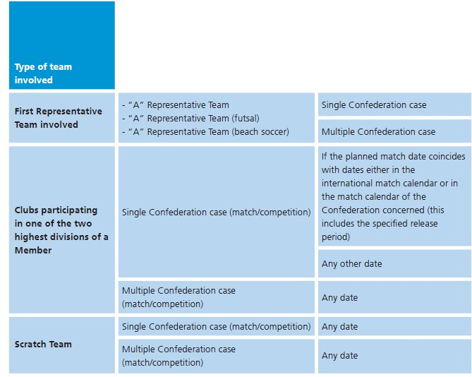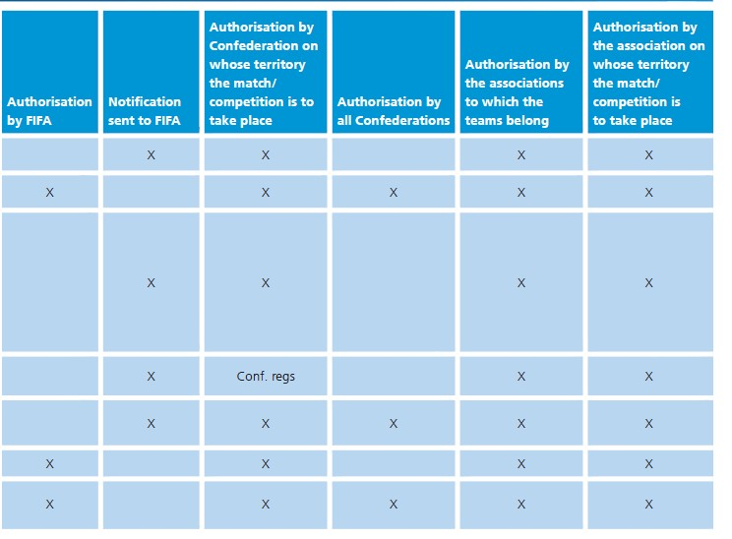 A **Tier 1 International Matches _Pic45**

**Key**

Conf. regs: Authorisation by/notification to the Confederation, to be determined by the Confederation’s regulations.

Single Confederation case: All participating teams belong to the same Confederation and the match/competition is taking place on the Confederation’s territory.

Multiple Confederation case: Either the participating teams belong to different Confederations or the match/competition is taking place on another Confederation’s territory than the one to which the teams belong. If this is the case, the Confederation on whose territory the match/competition is taking place shall have the final decision, but the other Confederation(s) shall have a “veto right” prior to this final decision.

20 附件：概述和批准授权的程序

**附件A** 1级国际比赛_Pic45

|  |  |  |  |  |  |  |  |  |
| --- | --- | --- | --- | --- | --- | --- | --- | --- |
| 球队类型 |  | | 需国际足联批准许可 | 需通知国际足联 | 需比赛举办地洲足联批准 | 需所属洲足联批准 | 需球队所属会员协会批准 | 需比赛举办地会员协会批准 |
| 一队代表队 | A队代表队  A队代表队（室内五人制）  A队代表队（沙滩足球） | 属于同一洲足联的情况 |  | X | X |  | X | X |
| 属于不同洲足联的情况 | X |  | X | X | X | X |
| 会员协会下属最高两级别联赛中的参赛俱乐部队 | 属于同一洲足联的情况（比赛/赛事） | 如果预定的比赛日与国际足联比赛日或相关洲足联比赛日发生冲突（包括规定的球员放行期） |  | X | X |  | X | X |
| 任何其他日期 |  | X | 洲足联规程规定 |  | X | X |
| 属于不同洲足联的情况（比赛/赛事） | 任何日期 |  | X | X | X | X | X |
| 临时组成的球队 | 属于同一洲足联的情况（比赛/赛事） | 任何日期 | X |  | X |  | X | X |
| 属于不同洲足联的情况（比赛/赛事） | 任何日期 | X |  | X | X | X | X |

注释：

洲足联规程规定 比赛是否需要洲足联批准许可和通知洲足联，由洲足联的规程规定

属于同一洲足联的情况 所有参赛队都属于同一洲足联，且比赛在该洲足联领土内举行的情况

属于不同洲足联情况 如果参赛球队属于不同洲足联，或比赛（赛事）在另一个洲足联领土内举行，则比赛或赛事所在地的洲足联拥有最终决定权，但在此决定做出之前其他相关洲足联有“否决权”。

21 **ANNEXES: OVERVIEW OF AUTHORISATION AND PROCEDURE**

B **Tier 2 International Matches**

**_Pic45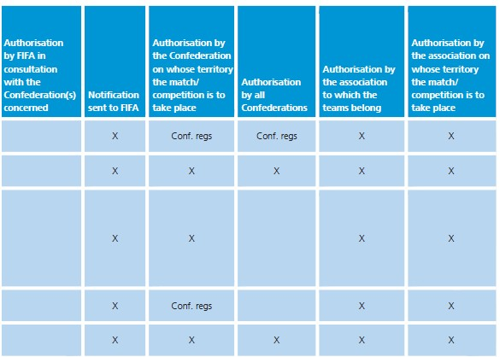**

**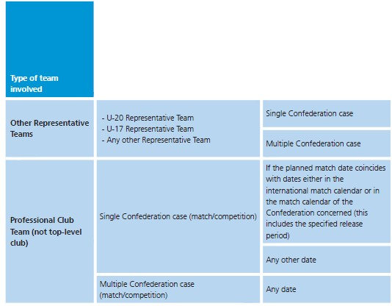**

**Key**

Conf. regs: Authorisation by/notifi cation to the Confederation, to be

determined by the Confederation’s regulations

Single Confederation case: All participating teams belong to the same Confederation and the

match/competition is taking place on the Confederation’s territory.

Multiple Confederation case: Either the participating teams belong to different Confederations

or the match/competition is taking place on another Confederation’s

territory than the one to which the teams belong.If this is the case, the

Confederation on whose territory the match/competition is taking place

shall have the fi nal decision, but the other Confederation(s) shall have a

“veto right” prior to this final decision.

21 附件：概述和批准授权的程序

**附件B** 2级国际比赛_Pic45

|  |  |  |  |  |  |  |  |  |
| --- | --- | --- | --- | --- | --- | --- | --- | --- |
| 球队类型 |  |  | 需国际足联批准 | 需通知国际足联 | 需比赛举办地洲足联批准 | 需所属洲足联批准 | 需球队所属会员协会批准 | 需比赛举办地会员协会批准 |
| 其他代表队 | U20代表队  U17代表队  其他任何代表队 | 属于同一洲足联的情况 |  | X | 洲足联规程规定 | 洲足联规程规定 | X | X |
| 属于不同洲足联的情况 |  | X | X | X | X | X |
| 职业俱乐部（非顶级联赛俱乐部） | 属于同一洲足联的情况（比赛/赛事） | 如果预定比赛日与国际足联比赛日或相关洲足联比赛日冲突（包括规定的球员放行期） |  | X | X |  | X | X |
| 任何其他日期 |  | X | 洲足联规程规定 |  | X | X |
| 属于不同洲足联的情况（比赛/赛事） | 任何日期 |  | X | X | X | X | X |

注释：

洲足联规程规定 是否需要洲足联批准许可和通知洲足联都由洲足联规程规定。

属于同一洲足联的情况 所有参赛队都属于同一洲足联，且比赛在该洲足联领土内举行。

属于不同洲足联的情况 如查参赛球队属于不同洲足联，或比赛（赛事）在另一个洲足联领土内举行，则比赛或赛事举行所在地的洲足联应拥有最终的决定权，但在此决定作出之前其他相关洲足联有“否决权”。

